Logo partner insitute   | Department: Clinical Sciences | Unit: Tropical Laboratory Medicine
APPENDIX 1: Initial identification flowchart for bacteria
isolated from an aerobic blood culture
 | Project/study: NA

This flowchart provides an initial identification of bacteria isolated from an aerobic blood culture, after the initial subculture of grown blood cultures has been done based on the Gram staining result (SOP TLM_PRO_109).

For Gram-positive bacteria, follow procedures described in TLM_PRO_047.
For Gram-negative bacteria, use the flowchart below based on the results of the following tests:
  - Oxidase (Ox) (see procedure TLM_PRO_055)
  - Kligler Iron Agar (KIA): (see procedure TLM_PRO_056)
    - Glucose-fermentation
    - Lactose-fermentation
    - H₂S-production
    - Gas-production
  - Growth characteristics on MacConkey (MC)
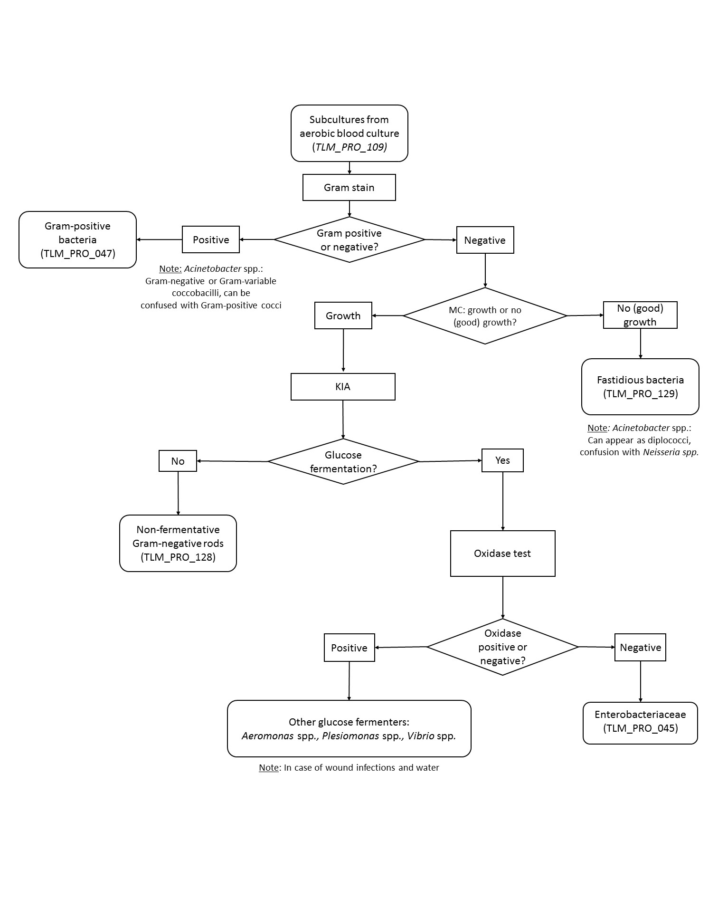

Note: some non-fermentative Gram-negative rods may also show poor growth on MacConkey agar, like Chryseobacterium spp., Brevundimonas spp., Burkholderia mallei, Acidovorax spp., Sphingomonas spp., …

Note: If biochemical reactions do not lead to a clear final identification result, think of Bacillus spp or Acinetobacter spp. These can be Gram-variable after staining. Verify by the following tests:
- Bacillus spp.: Gram-positive or Gram-variable
  - Perform a Gram stain on an ‘old’ colony (>24h post-incubation): Bacillus spp. show spores
  - Perform a Vancomycin 30 µg susceptibility test (TLM_PRO_109). Gram-positive bacteria, including Bacillus spp. are susceptible to Vancomycin, showing an inhibition zone around the Vancomycin 30 µg disk.
  - Confirm by following biochemical tests described in the identification procedure for Gram-positive bacteria (TLM_PRO_0047)
- Acinetobacter spp.: Gram-negative or Gram-variable coccobacilli, which can be confused with Gram positive cocci. Can appear as diplococci (confusion with Neisseria sp.). See the identification procedure of Gram-negative non-fermentative rods TLM_PRO_128

References
- Amy L. Leber, ASM Press, Clinical Microbiology Procedures Handbook, 4th edition, 2016
- Slides GMCH Dept Microbiology DR. Anindya Das
- https://www.wiv-isp.be/QML/activities/external_quality/rapports/ATLAS/Bacteriology/Gram-negative-aerobic-and-facultative-rods.pdf
Records and archives

Appendices & Forms for completion
Number | Title
NA | NA

Revision
Changes with respect to the previous version | Initial version

Name and function | Date | Signature
Author
Anne-Sophie Heroes | 27/05/2019
Reviewed by
Barbara Barbé  Sien Ombelet | 29/05/2019
Approved by
Jan Jacobs | 31/05/2019

